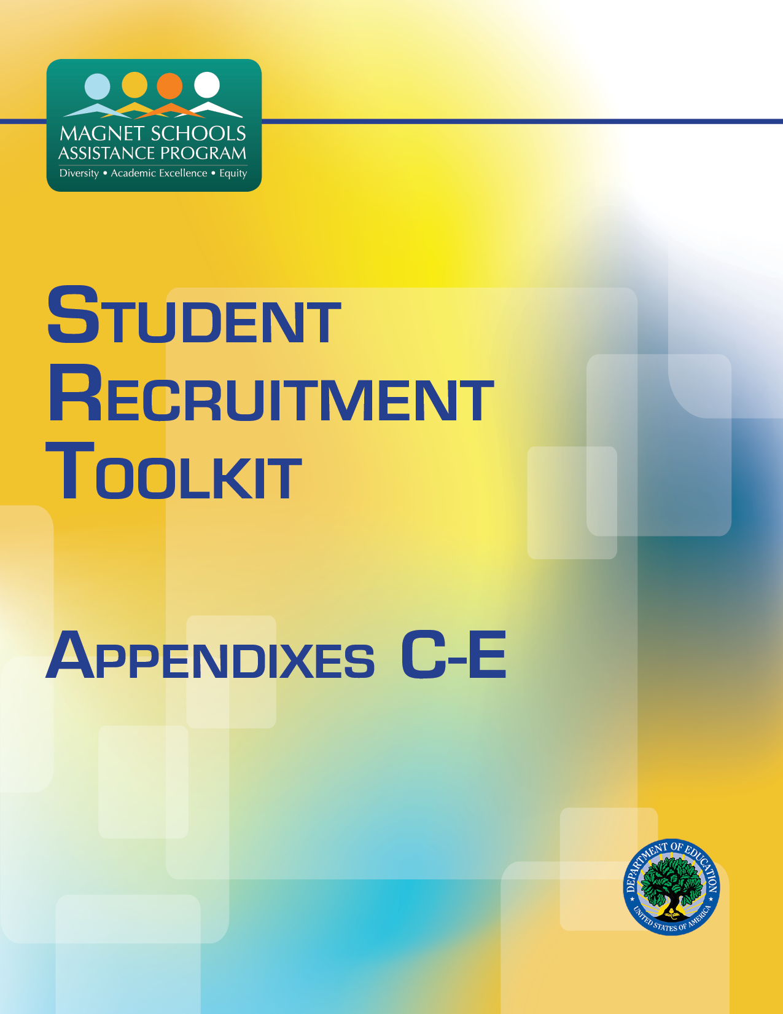

Appendix C
Checklists

Data Availability Checklist
Instructions: Use this checklist to identify the types of extant data that are available for marketing. Determine if each type of data listed in the matrix is available to you, and add other types of available data not listed in the matrix. Next, determine and note any needed information that is missing from the available data. Then, list the next steps required to obtain the missing information or alternative information that meets your needs. Revisit the checklist regularly as new data become available.
Type of data | Are these data available? | What needed information is missing from the data? | Next steps
Mailing lists
Census
Student application
Prospective student inquiries
Student enrollment
Student achievement
Student retention
Branding awareness
Other

Branding Checklist
Instructions: Indicate whether you have implemented the items in the matrix to build your brand. If you have not implemented an item, write in “Next steps” if and how you plan to implement it. If you have implemented an item, write if and how you plan to improve on implementation.
Branding item | Yes/No | Next steps
We have developed a branding strategy that explains what we want the community to know about our school and how we will communicate it.
Staff members are aware of the brand and image the school wants to project.
We have communicated our branding strategy to community stakeholders.
We have designed a logo and tagline that reflect the image we want to project.
The logo can be resized to fit on many different types of materials while still appearing attractive and legible.
Our logo includes the school colors.
Our logo works well in black and white.
The magnet theme is mentioned on all marketing materials.
All marketing materials include the logo, tagline, contact information, and web address.
Guidelines have been established for marketing materials (e.g., font, placement of logo, wording).
Templates have been created for materials (e.g., e-mail signatures, headers and footers, newsletter).
The use of guidelines and templates is regularly reviewed.
An approval process is in place for all marketing materials.

Website Checklist
Instructions: Indicate whether your website meets the following protocols. Then list next steps for implementing an item or improving its implementation.
Website item | Yes/No | Next steps
The magnet theme is evident within a few seconds of viewing the site.
Appropriate information about the MSAP school is readily available for prospective parents.
Website images and design reflect the school mission and objectives.
The website is inviting and uncluttered.
All website information is current.
Website navigation is user friendly.
Photos and videos show students active and engaged.
Photo captions describe the benefit of the activity to students, not just what is happening.
Website marketing information has clear “calls to action” (e.g., sign up for e-mail newsletter, follow us on social media, register for a tour, purchase school merchandise or event tickets, and contact us).
The website works in all major browsers (i.e., Internet Explorer, Firefox, Chrome, Safari).
The website is formatted for mobile devices.
The website appears in relevant Internet searches.
Website usage data are collected.

E-mail and Direct Mail Marketing Checklist
Instructions: Indicate whether your mailings meet the following protocols. Then list ideas for improving or implementing them.
Mail marketing item | Yes/No | Next steps
We maintain a marketing schedule that complements our other marketing activities.
We do not send more than one mailing per week to individuals on our mailing lists.
We use mailing templates with our school brand.
We include “join our mailing list” forms on our website, in newsletters, and at events.
Our mailing lists are segmented by audience.
We regularly update our mailing lists by removing information for old contacts, bounced-back e-mails, and returned mail.
Every mailing’s design and layout make our correspondence attractive and easy to read.
Every mailing lists the most important item first so it is the first thing a recipient sees when he or she opens it.
Every mailing includes at least one call to action (e.g., visit the website, book a school tour).
Every mailing contains clear and simple instructions for responding to a call to action.
Every mailing subject line is 5-7 words long, interesting, and relevant.
Every mailing mentions a benefit our school provides to students and their families.
We use an e-mail marketing program that tracks delivery, open rates, spam, bounce back, etc.
Our marketing e-mails contain a mix of elements, with text making up no more than 60 percent of the total. Interactive elements are provided in the form of links, videos, and photographs.

Social Networking Marketing Checklist
Instructions: Indicate whether your social networking activities meet the following protocols. Then list ideas for improving or implementing them.
Digital marketing item | Yes/No | Next steps
We utilize a variety of social networking platforms (e.g., Facebook, Twitter, YouTube, Google, and Pinterest).
We use consistent branding and images across all platforms.
We update our social networking platforms regularly (at least three times per week).
Our social networking pages contain appropriate information about school events and activities that appeal to current and prospective families.
Our social networking information is promoted on all marketing materials.
Our social networking marketing campaigns are timed to complement our other marketing campaigns.
Our social networking marketing campaigns make clear calls to action.
Our social networking marketing includes contact information.
We involve students in creating content and ideas for our social networking marketing campaigns where appropriate.
We monitor and influence content that is posted by the public on the school’s social networking pages.
We address concerns about our school found on social networking pages in our marketing campaigns.

Public Relations Checklist
Instructions: Indicate whether your public relations activities meet the following protocols. Then list ideas for improving or implementing them.
Public relations item | Yes/No | Next steps
Our staff members attend events and meetings hosted by community organizations, such as the Chamber of Commerce, the library friends group, and others.
We have a positive relationship with the local press.
We work proactively with the district Communications Office to coordinate positive press about our school.
We send out press releases regularly.
We have a process in place for staff to share newsworthy items with the administration.
We have a partnership program that encourages local businesses to become involved with the school.
We recognize and celebrate the contributions of our volunteers.
We host community events to increase the school’s visibility.

Press Release Checklist
Instructions: Indicate whether your press releases meet the following protocols. Then list ideas for improving or implementing them.
Press release item | Yes/No | Next steps
The press release is one page or less.
The press release communicates information about a recent or coming event or development rather than a general marketing message.
The press release answers who, what, when, where, why, and how.
The press release includes a paragraph at the end describing the school or program that submitted the release.
The press release is sent to media outlets that we determine are relevant based on research.
The press release includes a quote or testimonial.
The press release includes at least one relevant visual.
The press release is free from typos and errors.
The press release contains facts that have been verified.

Appendix D
Planning Tools
Marketing Plan
Instructions: Use this tool to develop a detailed marketing plan. Enter the school’s mission statement and SWOT analysis. For each phase of the funnel, insert one to three measurable marketing objectives in the matrix. Then list marketing activities that will help you meet all the objectives; make sure you keep the activities to a manageable number.
MSAP school mission:
SWOT analysis
- Strength:
- Weakness:
- Opportunity:
- Threat:
Phase of funnel | Marketing objective | Marketing activities
Prospects
Inquiries
Applications
Admitted
Enrollees
Retained

Activity Calendar
Month: (Enter month and year)
Instructions: Use this tool to organize your marketing activities into manageable timelines. Transfer the activities from the Activities column of the Marketing Plan Tool to the Activities column of this matrix. Enter a date when each activity should be completed. Consider breaks and holidays when establishing due dates, and add them to the Special Notes column. Insert name of the person(s) responsible for coordinating the activity. Set measurable goals for each activity so you can assess its effectiveness. Complete a separate activity calendar for each month.
Completion Date | Activity | Staff assigned | Goals | Special notes

Activity Assessment—Event
Instructions: Use this tool to list all the required steps for implementing a marketing event. Based on the total budget for the event, itemize the costs for each step. Working backward from the date of the event, enter a realistic due date for each step. As the steps occur, fill in the dates completed, expended costs, and the outcomes. Conduct a final assessment of these items to measure the event’s success.
Activity:
Goal:
Steps | Due date | Date completed | Budget allocated | Budget expended | Outcomes
Event date

Activity Assessment—E-mail and Direct Mail Campaigns
Instructions: Use this tool to continuously track your e-mail and direct mail campaigns during the year. Enter each mailing’s sent date, subject, targeted group, and number sent in the corresponding columns. Then enter the number of e-mail bounce backs or returned mail, number of e-mails opened, and number of click-throughs to your website. Document changes in website traffic and the number of attendees who responded to the mailing’s call to action. These numbers will help track the outcomes of your mailings and identify trends to determine which campaigns were most effective. You may want to organize e-mail or direct mail campaigns into discrete steps that you track using a separate Activity Assessment—Other tool.
Activity:
Goal:
Date sent | Subject of mail | Number sent | Targeted group | Number of bounces or returns | Number of e-mails opened | Number of click-throughs to website | Change in website traffic | Number of people responding to call to action

Activity Assessment—Other
Instructions: Use this tool to identify the required steps for implementing marketing activities other than events and mailings. List all the steps that must occur for the other activity to happen. Based on the total budget for activity, itemize the costs for each activity step. Working backwards from the date of the activity, enter a realistic due date for each step. As the steps occur, fill in the dates completed, expended costs, and the outcomes. Conduct a final assessment of these items to measure the success of the other activity.
Activity:
Goal:
Steps | Due date | Date completed | Budget allocated | Budget spent | Outcomes
Overall

Funnel Tracking Sheet
Instructions: Use this tool to track the number of students in the targeted and racially isolated groups recruited during each phase of the funnel. At the end of each month, enter the numbers for each group and update the Total column. Use the totals to track your progress against the targeted numbers the school must recruit based on the Student Recruitment Calculator.
Student |  | Aug | Sept | Oct | Nov | Dec | Jan | Feb | Mar | Apr | May | Jun | Jul | Total
Prospects | Targeted group
 | Isolated group
Inquiries | Targeted group
 | Isolated group
Applicants | Targeted group
 | Isolated group
Admits | Targeted group
 | Isolated group
Enrollees | Targeted group
 | Isolated group
Exiting | Targeted group
 | Isolated group

Appendix E
Data Collection Tools

Website Experience Survey

- Are you a: (1) current parent, (2) prospective parent, or (3) other
- How long did it take you to find information on:
 | Less than 30 seconds | 30-60  seconds | 1-3 minutes | More than 3 minutes | Unable  to find
Magnet theme
Magnet curriculum/instruction
Community partnerships
Academic achievement
Teacher quality
School safety
Parent involvement
Extracurricular activities
Contacting school
Booking a school tour
(Add other relevant items)

- What did you like most about the website?

- What did you like least about the website?

- What additional information would you like on the website?

- Would you visit the school or recommend a school visit based on the website? Yes/No

- Would you send your child or recommend that someone send a child to this school based on the website? Yes/No

- Additional comments:

Brand Awareness Survey

- When thinking about schools, name the first neighborhood school that comes to mind.

- Are you familiar with the Enter MSAP School Name?
  - Yes
  - No

- Do you know the mission of Enter MSAP School Name?
  - Yes If yes, please state what it is:
  - No

- Do you know the magnet theme (s) of Enter MSAP School Name?
  - Yes If yes, please state what it is:
  - No

- Circle the current logo for Enter MSAP School Name.
(Insert images)

- Write three other things you know about Enter MSAP School Name.

Parent Satisfaction Survey
- Please use these ratings to indicate your satisfaction with the following:
 | Very  satisfied | Satisfied | Dissatisfied | Very  dissatisfied | Do not know
  - Magnet theme-based instruction
  - Course selection
  - Instructional staff capabilities
  - Instructional staff credentials
  - Magnet-related partnerships
  - Diverse learning experiences
  - School leadership
  - Friendliness of school staff
  - Extracurricular activities
  - School safety
  - Availability of technology
  - Technology use in instruction
  - Emphasis on family involvement
  - Student academic achievement
  - Preparation for college and career
  - Student diversity
  - Staff diversity
  - Instruction about diverse cultures
  - School reputation
  - School transportation
  - Receptiveness to parent feedback
  - Receptiveness to student feedback
  - Overall child’s education

- What do you like most about MSAP School Name?

- What do you like least about MSAP School Name?

- Would you recommend this school to a friend?

- Additional comments:

Exit Interview
Student name:
Student grade level:
Student class assignment:

- What initially attracted you to our school?
- What were your primary reasons for enrolling your child?
- What aspects of the school satisfied or exceeded your expectations? (Please be specific)
- What aspects of the school failed to meet your expectations? (Please be specific)
- Why factors influenced your decision to leave the school?
- What factors would encourage you to stay at the school?
- Would you recommend the school to other parents and students? If yes, what would you say, and if not, why?
- What is the name of the school that you will attend next?
- Indicate the type of the next school:
  - traditional public school
  - magnet school
  - charter school
  - private school
  - parochial school
  - other

